***PDA Evidence***

Week 2 – I&T I.T.5

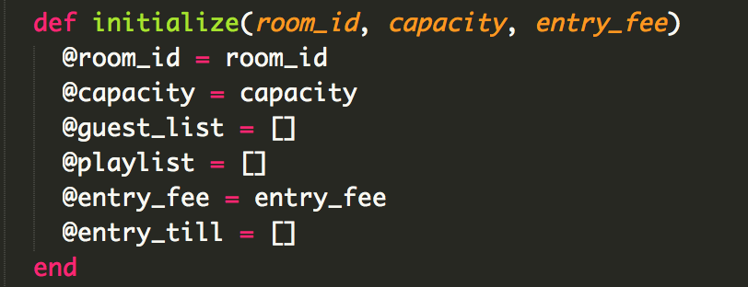

Screenshot above shows an array in a program - @playlist, @entry_fee, @entry_till.

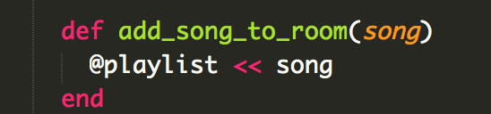

Screenshot above shows the array being used in a function – song being added to the @playlist array.

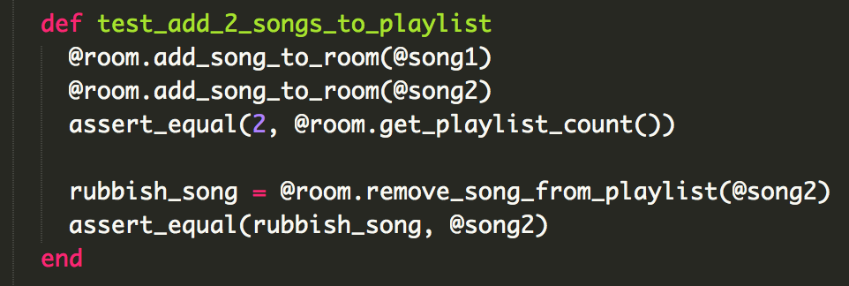

Screenshot above shows the function test that shows that a song can be added to the playlist.

Week 2 – I&T I.T.6

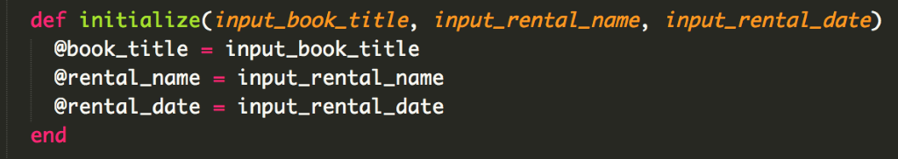

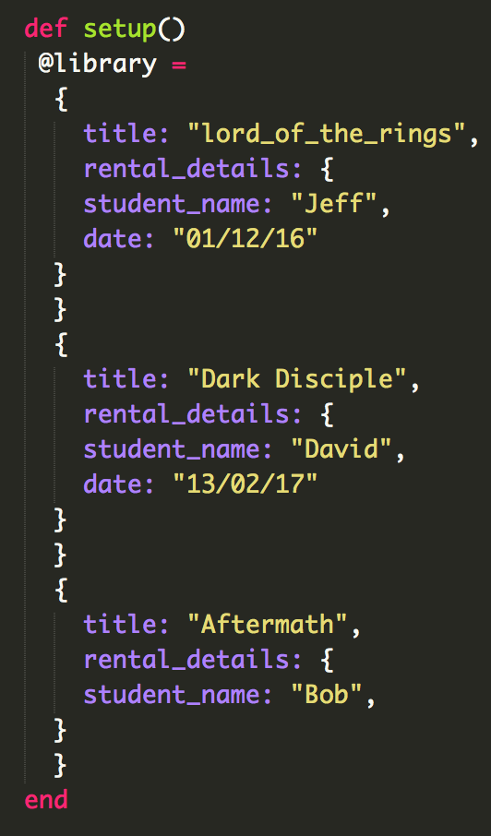

Screenshots above shows a hash in a program and the data being passed into the hash.

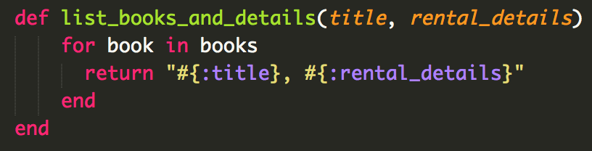

Screenshot above shows a hash in a program - #{:title}, #{:rental_details}.

Week 3 – I&T I.T.3

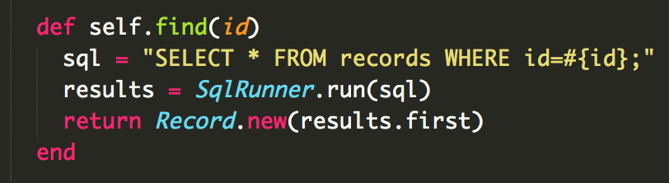



The above screenshots shows a search function and the results of that search function.

Week 3 – I&T I.T.3

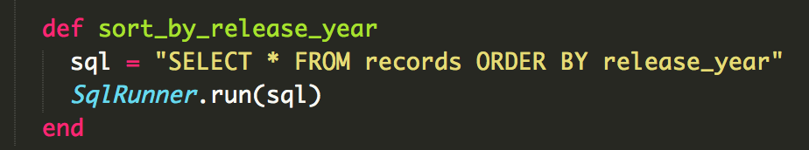

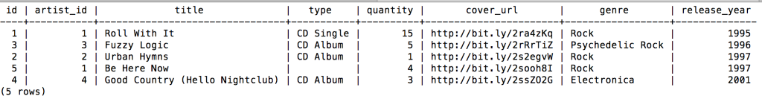

The above screenshots shows a function that sorts by release year and the result of that sorting function.

Week 5 – A&D A.D 1

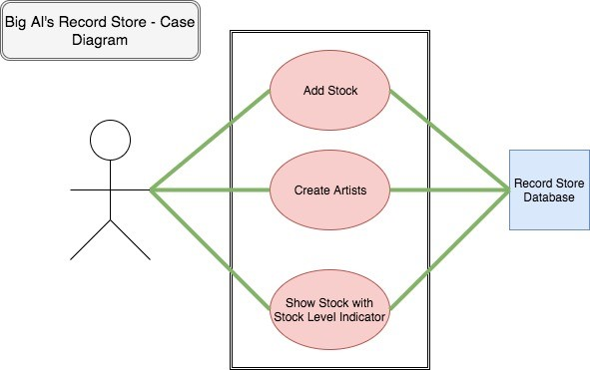

Screenshot above shows a Case Diagram.

Week 5 – A&D A.D 2

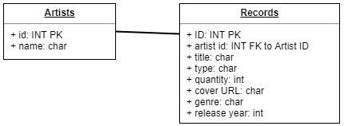

Screenshot above shows a Class Diagram.

Week 5 – A&D A.D 3

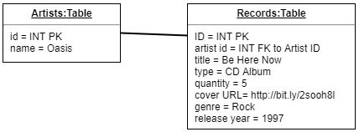

Screenshot above shows an Object Diagram.

 Week 5 – A&D A.D 4

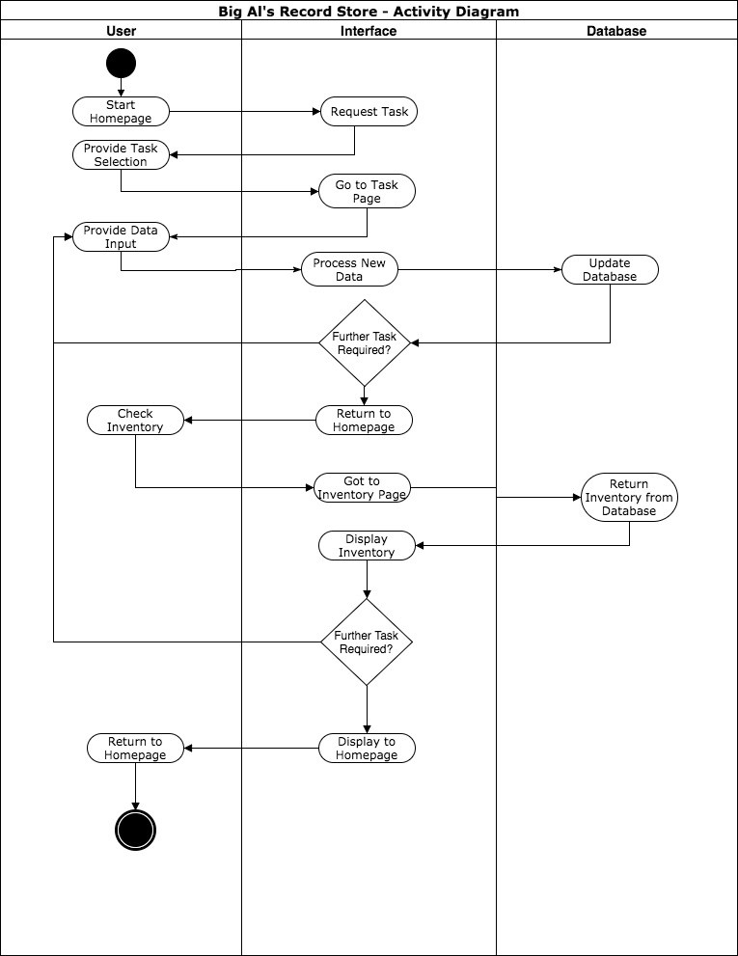

Screenshot above shows an Activity Diagram.

Week 5 – A&D A.D 6

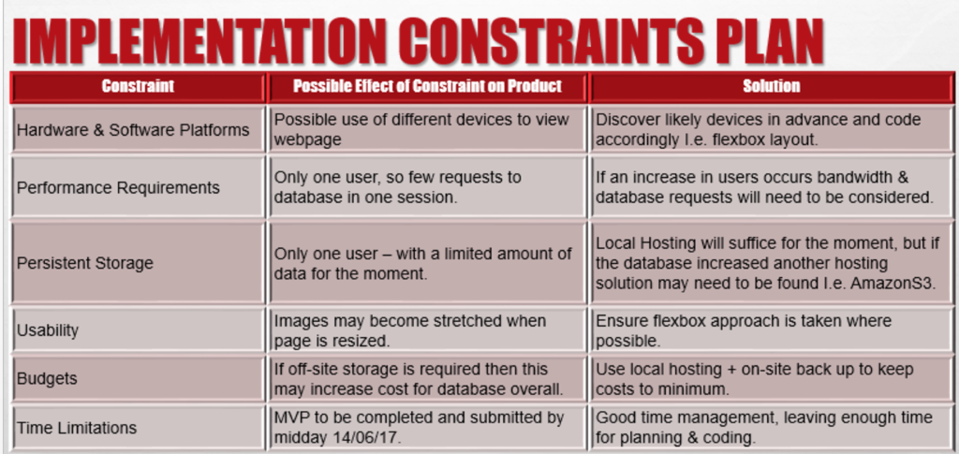 Above is a Implementation Constraints Plan.

Week 5 – P P5

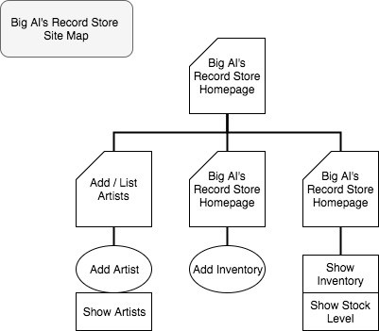

Above is a Site Map.

Week 5 – P P6

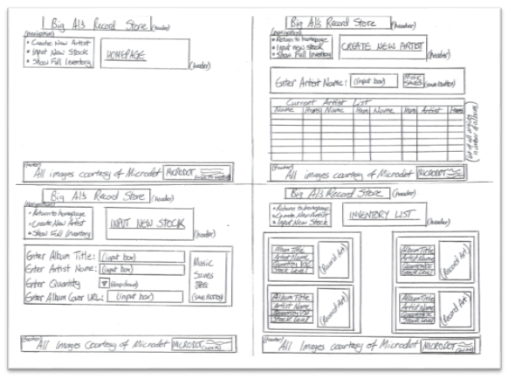

Above picture is 4 Wireframe Diagrams.

Week 5 – P P10

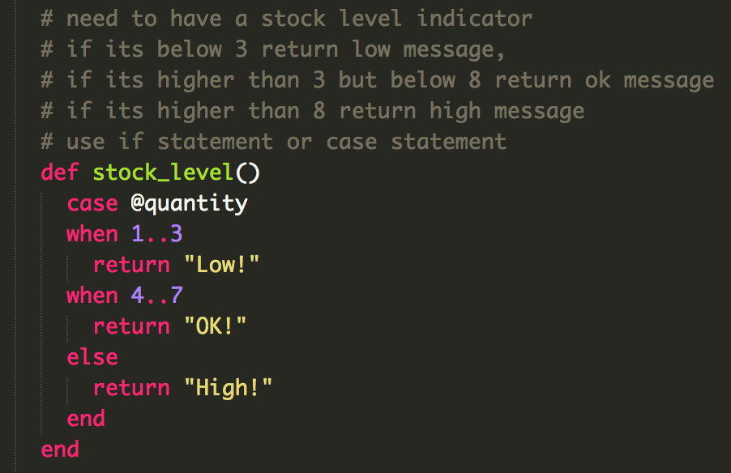

The above screenshot shows pseudocode being used to layout what conditions a case statement should have.

Week 5 – P P13

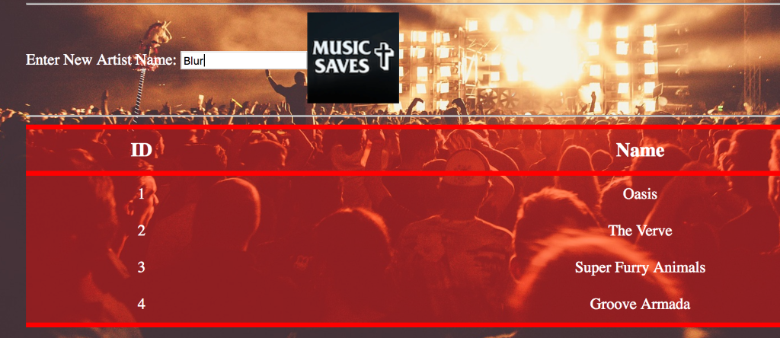

Above screenshot shows Blur being entered as a New Artist.

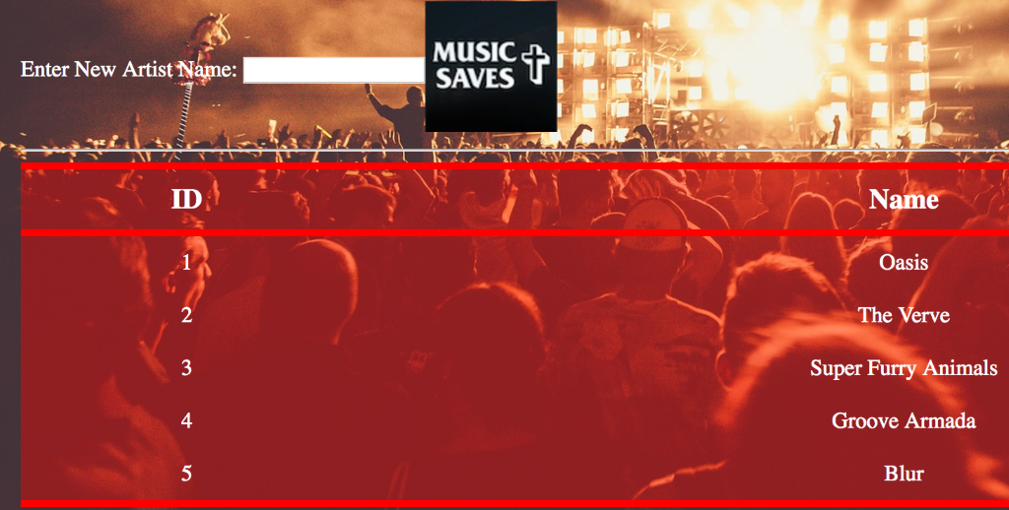

Above screenshot shows that the artist Blur has been added to the artists database and is being displayed on the web page.

 Week 5 – P P14

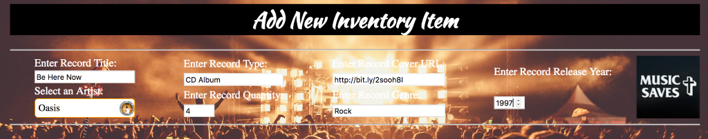

Above screenshot shows a new item being added to the inventory.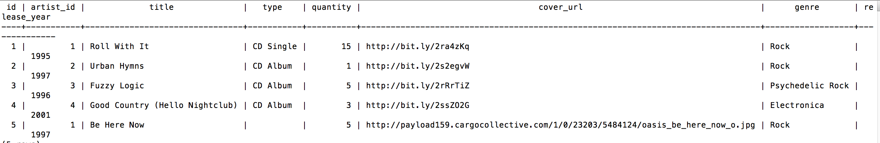

Above screenshot shows that the new item has been saved to the database.

 Week 5 – P P15

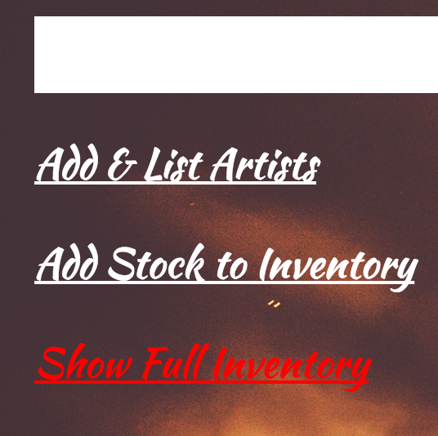

Above screenshot shows the Show Full Inventory option being clicked on, as the font changes colour when the mouse hovers on it.

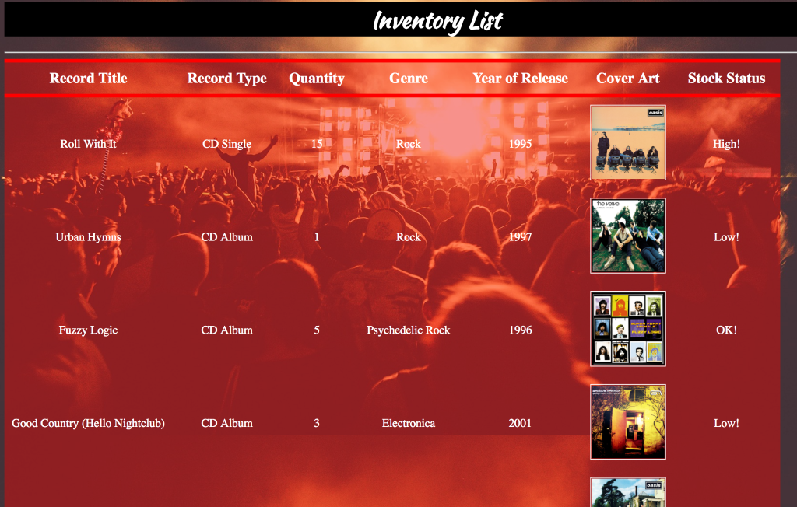

Above screenshot shows the Inventory List after chosen navigation has been clicked on the previous screenshot.

Week 6 – I&T I.T 7

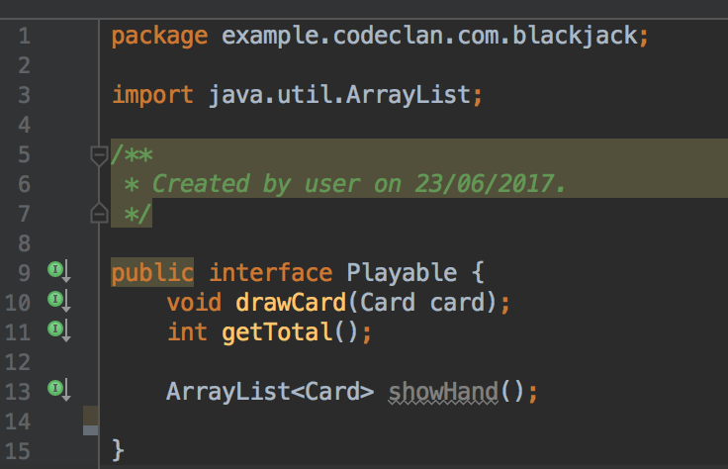

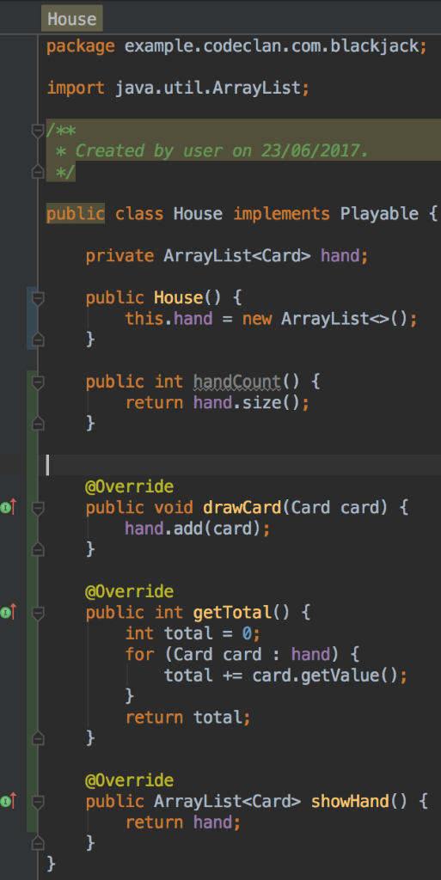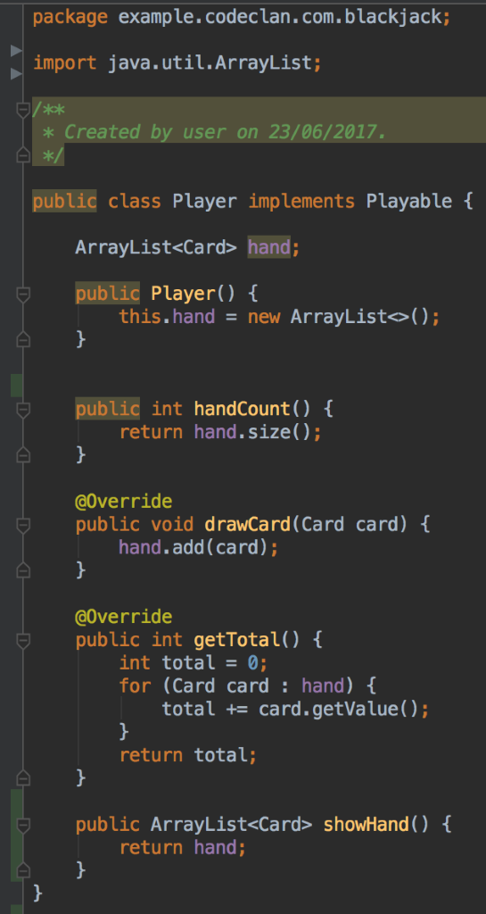

The above screenshot shows Polymorphism as the Player and House class implement the Playable interface class.

Week 7 – A&D A.D 5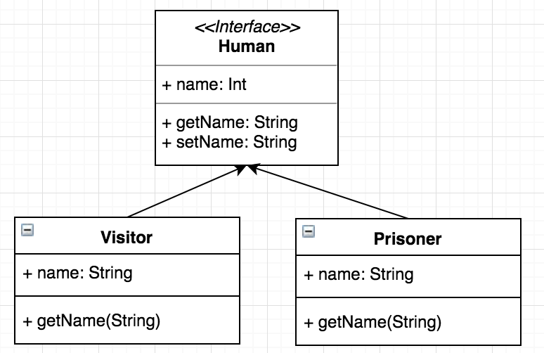

The above screenshot shows an inheritance diagram.

Week 6 – I&T I.T 1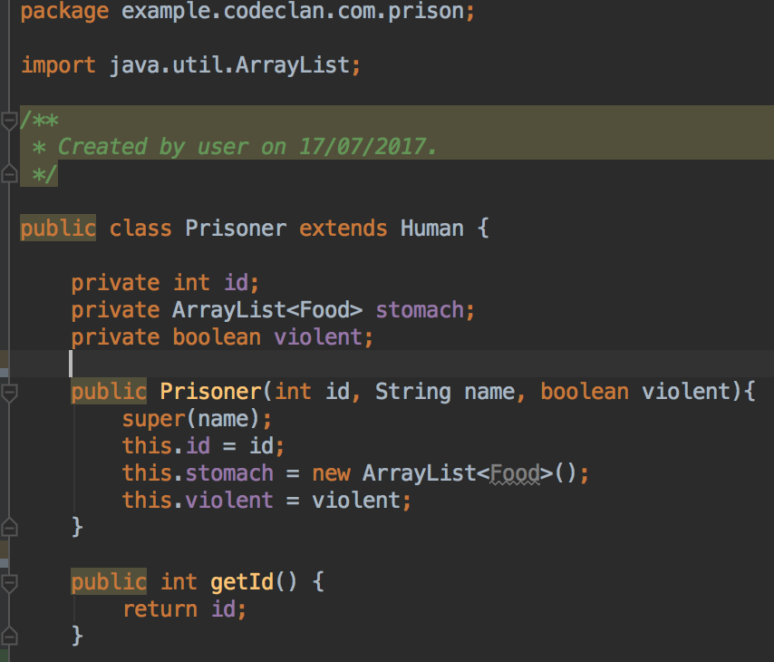

The above screenshot shows encapsulation as the properties of the Prisoner class are private but the methods are public - adhering to the open/close principle.

Week 7 I&T I.T. 2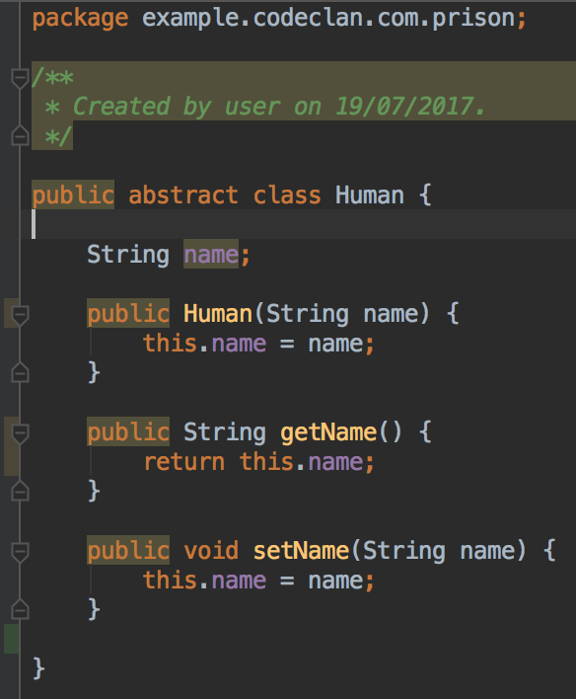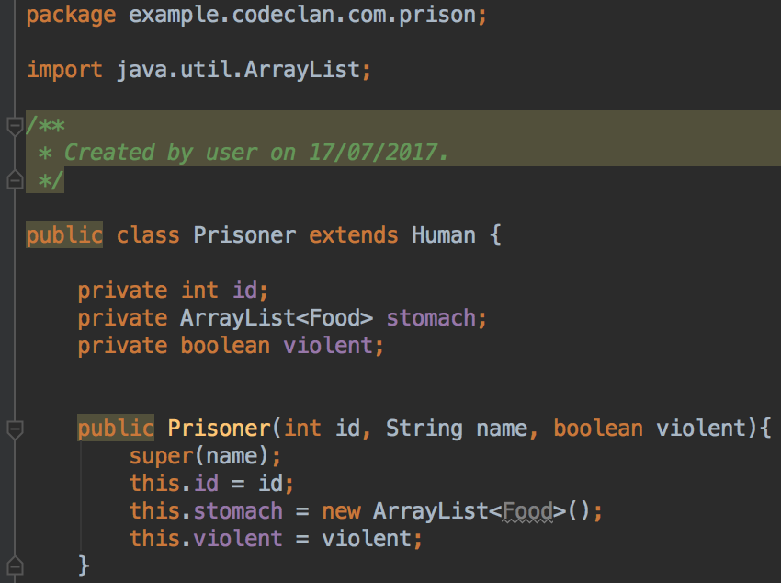

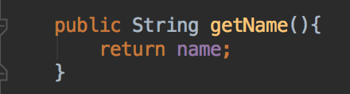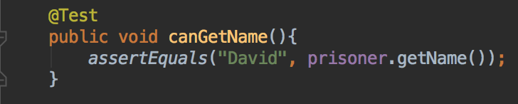

The above screenshots show inheritance, where the name for the prisoner is inherited from the Human class.

Week 7 P P11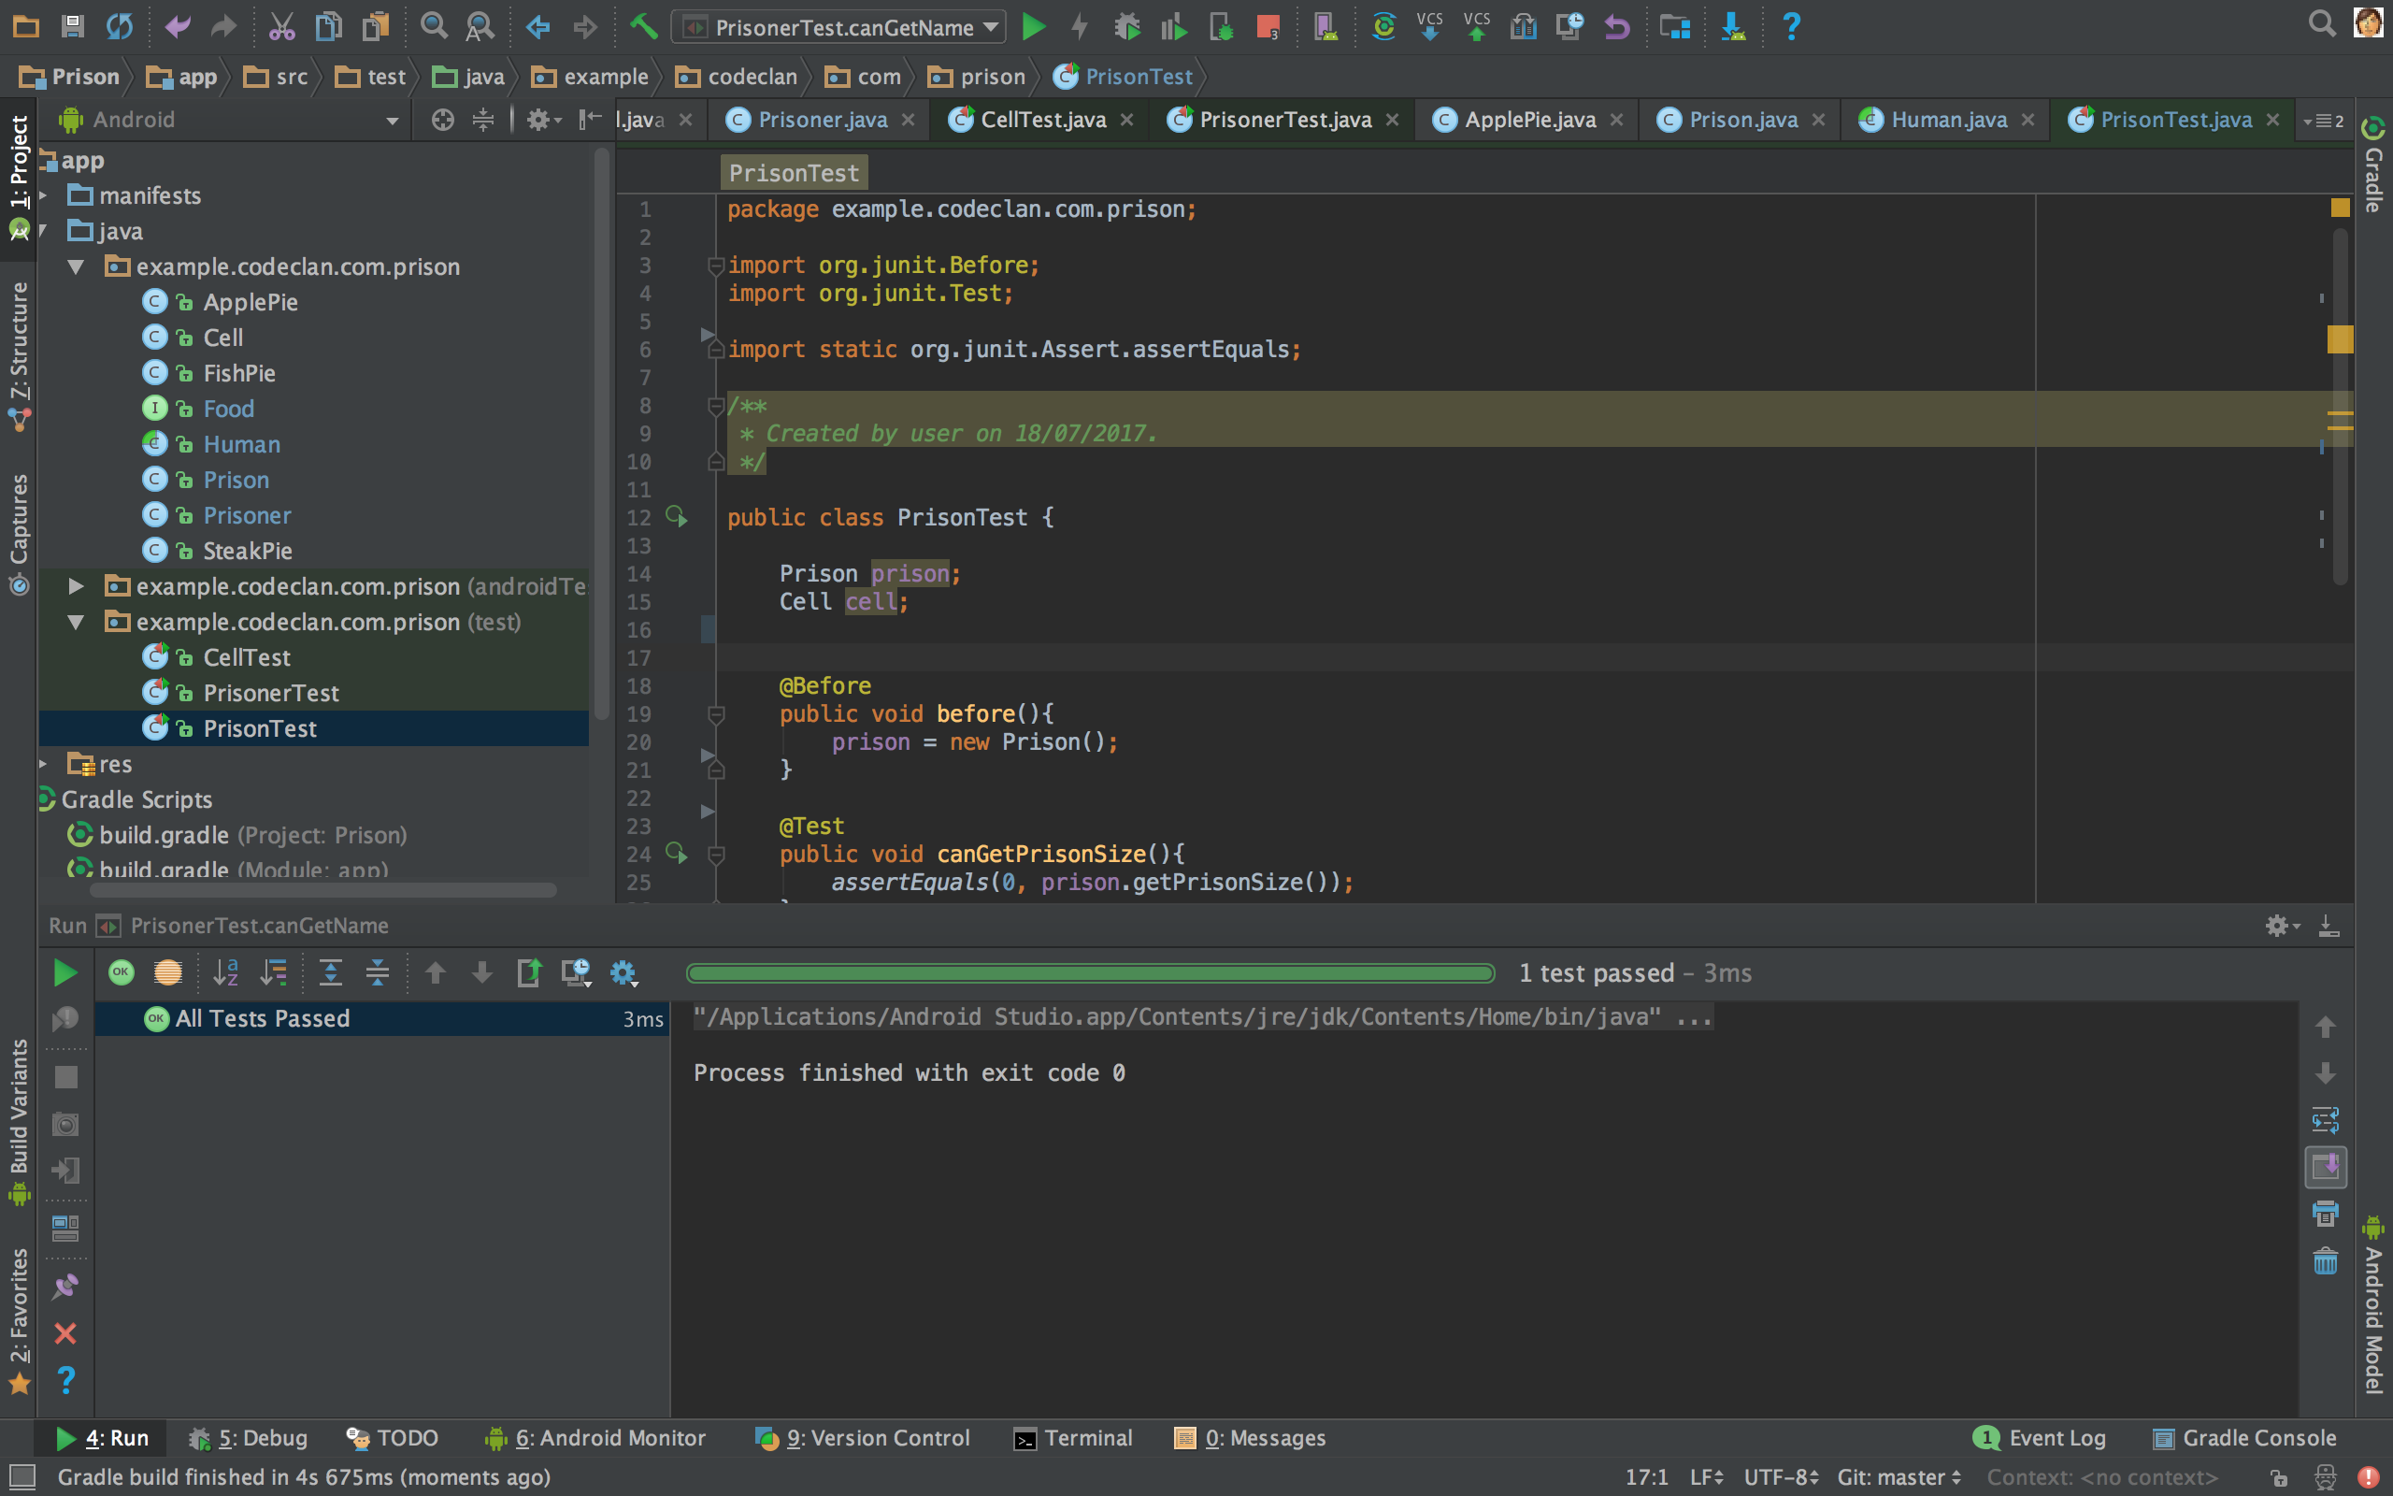

The above screenshot is of the Java project that I worked solo on.

It can be found at this GitHub link;

<https://github.com/clarkee013/Prison_Homework>

Week 7 P P12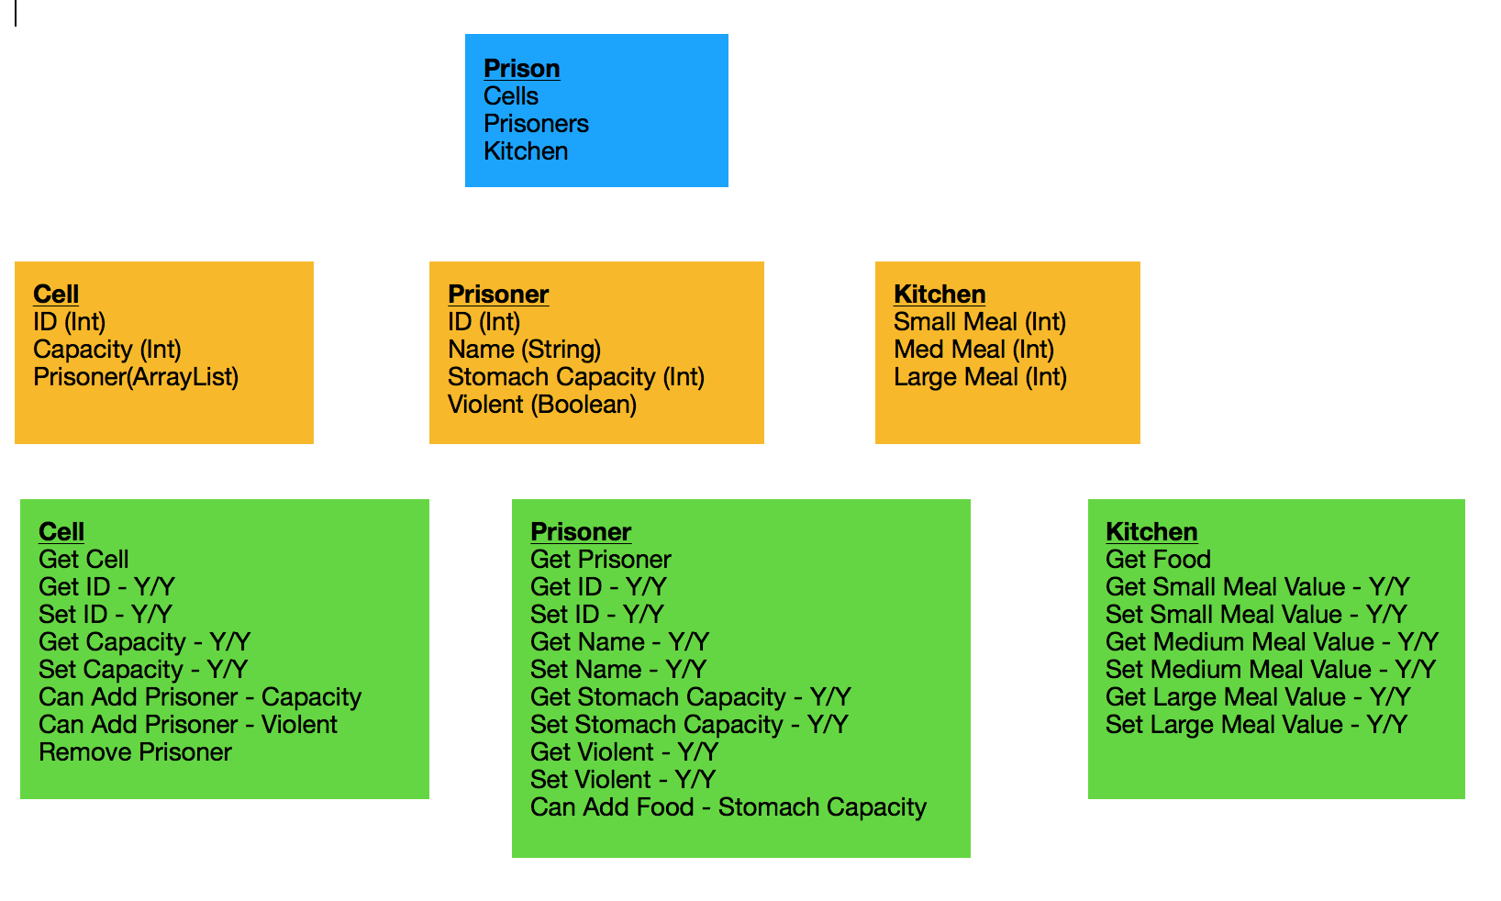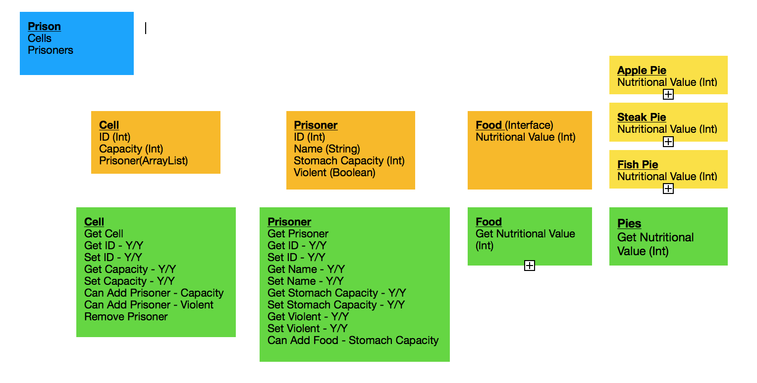

The above screenshot shows different stages of planning for my Prison Java project - earlier stage on the left and later stage on the right.

Week 10 P P18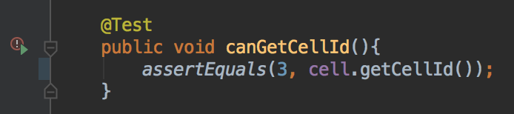

The above screenshot above is of a test for the Cell ID.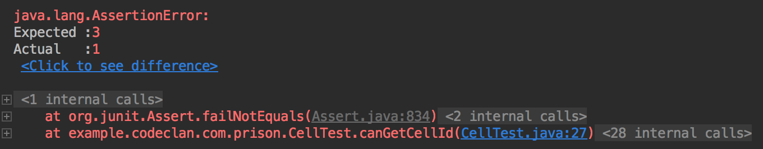

The above screenshot is of the test failing.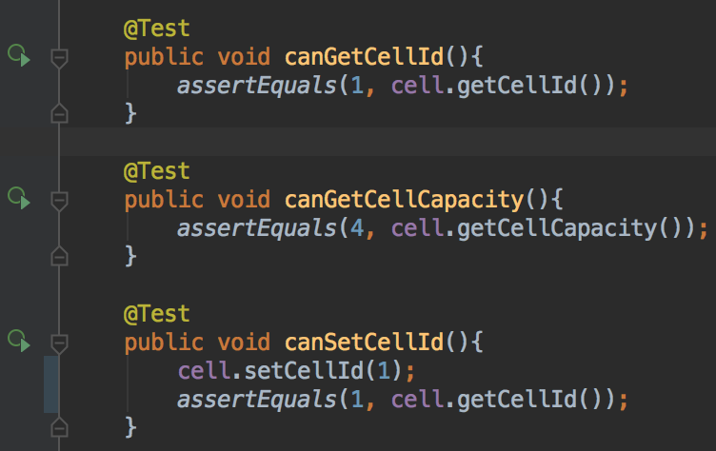

The above screenshot is of correction made to the test code.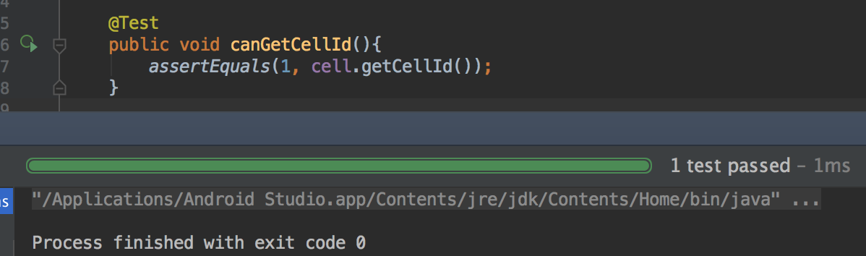

The above screenshot is of the test code passing as noted by the green icon to the left of the code (bigger example to left of screenshot).

Week 11 P P16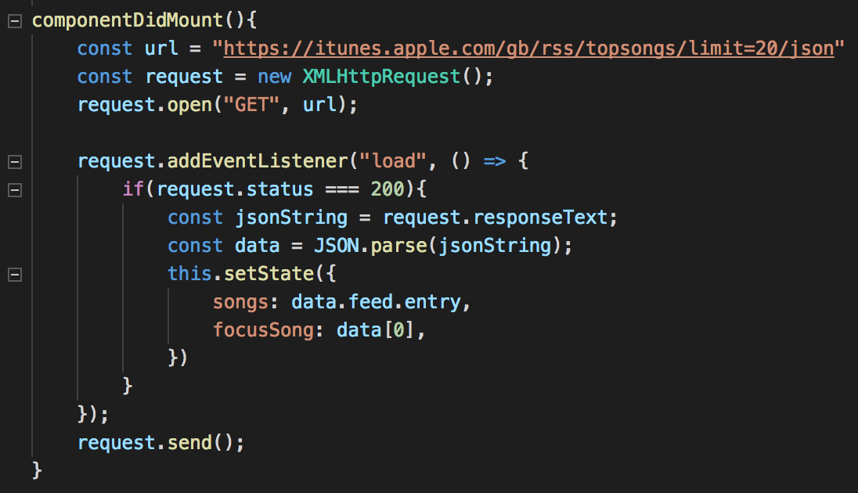

The above screenshot shows the iTunes top 20 songs API being used in the program.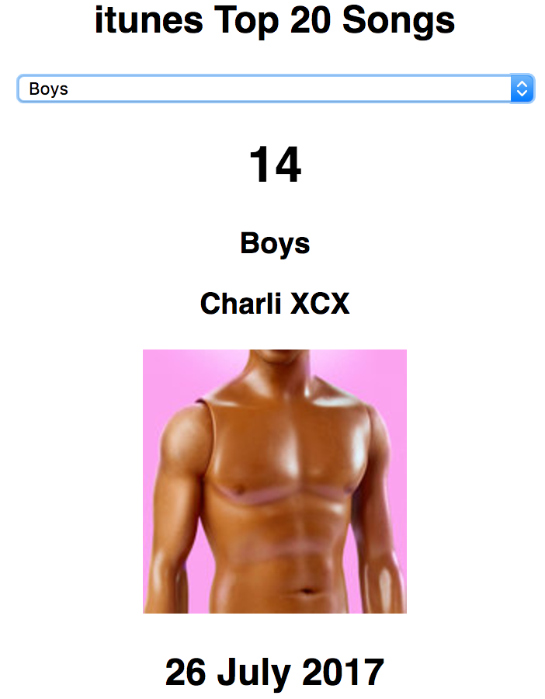

The above screenshot shows the iTunes API being used in a web page.

Week 13 P P1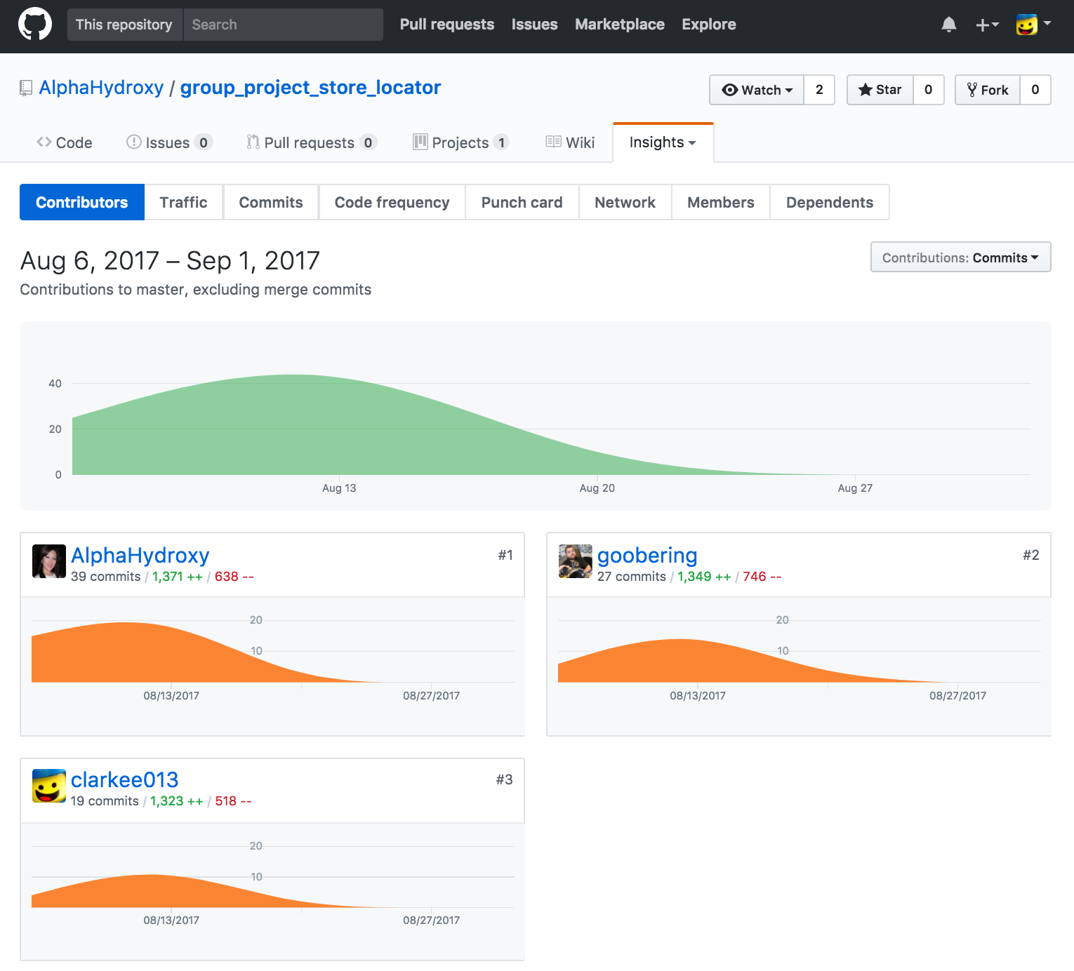

The above screenshot is of the group project contributor’s page on GitHub showing the 3 members of the team.

Week 13 P P2

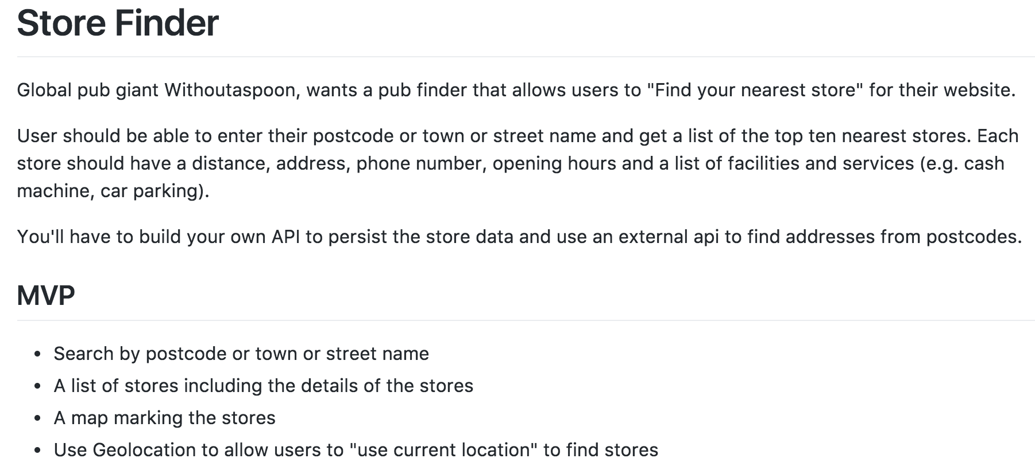

The above screenshot shows the specs for the group project.

Week 13 P P3

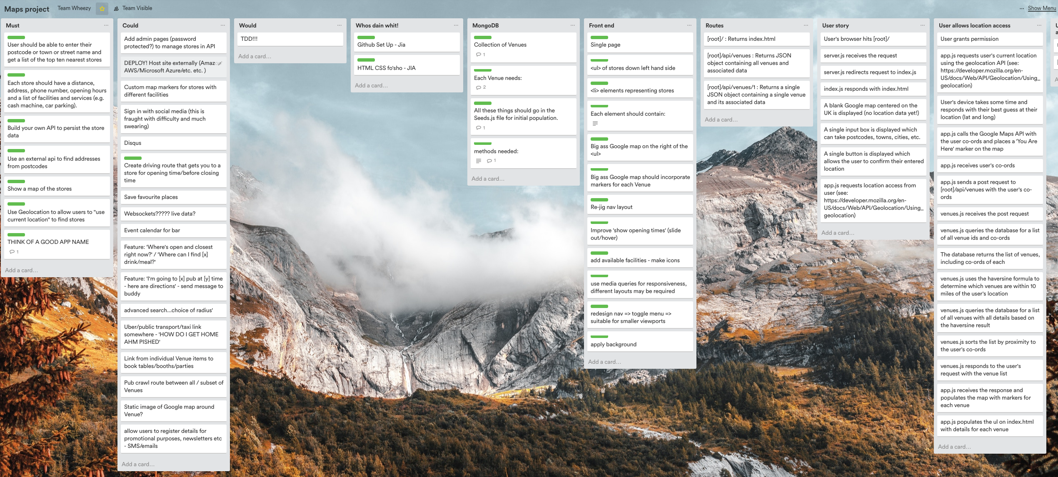

The above shows the Trello board for the group project.

Week 13 P P4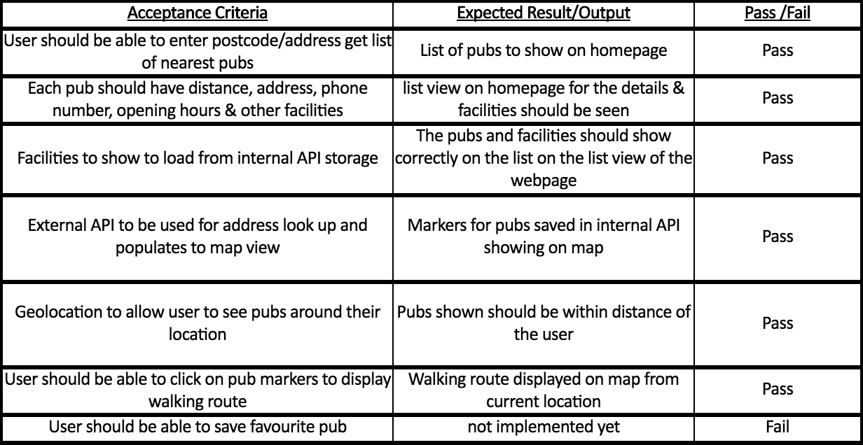

The above shows an Acceptance Criteria test plan in relation to the group project.

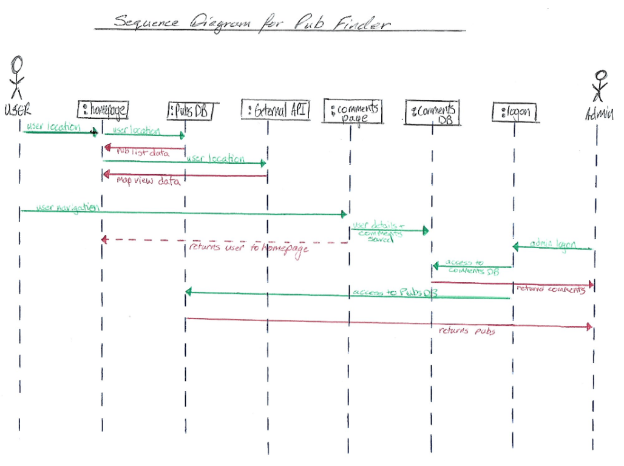

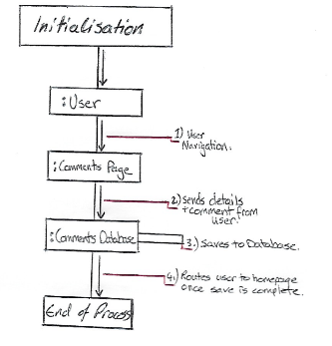

The above screenshots are a sequence diagram for the group project and a colloboration diagram for the comments page for the group project (Pub Finder)

Week 13 P P8

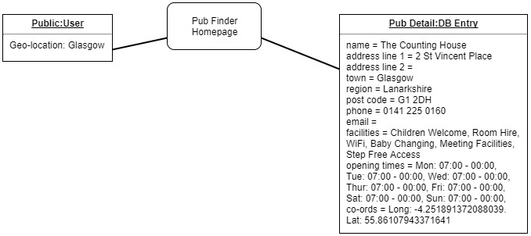

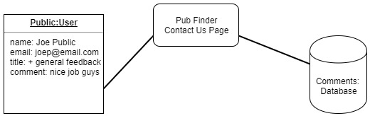

The above screenshots are of an object diagrams.

Week 13 P P9

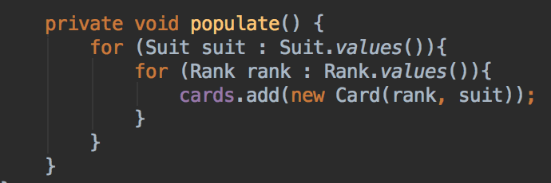

The above screenshot shows an algorithm I created to loop through each suit (4) and attribute a value to each card for each rank (13) available.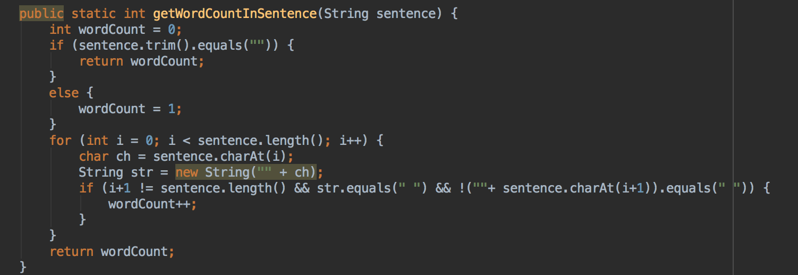

The above screenshot shows another algorithm that I created for checking the number of letter within a word and returning a string sentence to confirm that number.

Week 13 P P17

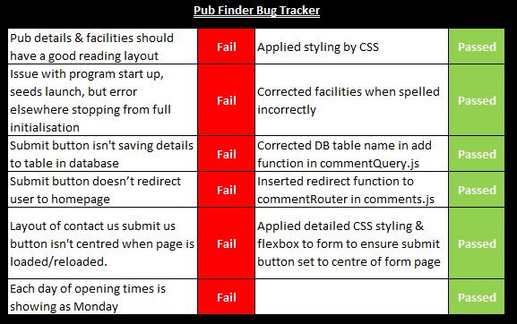

The above screenshot shows a bug tracker for the group project.